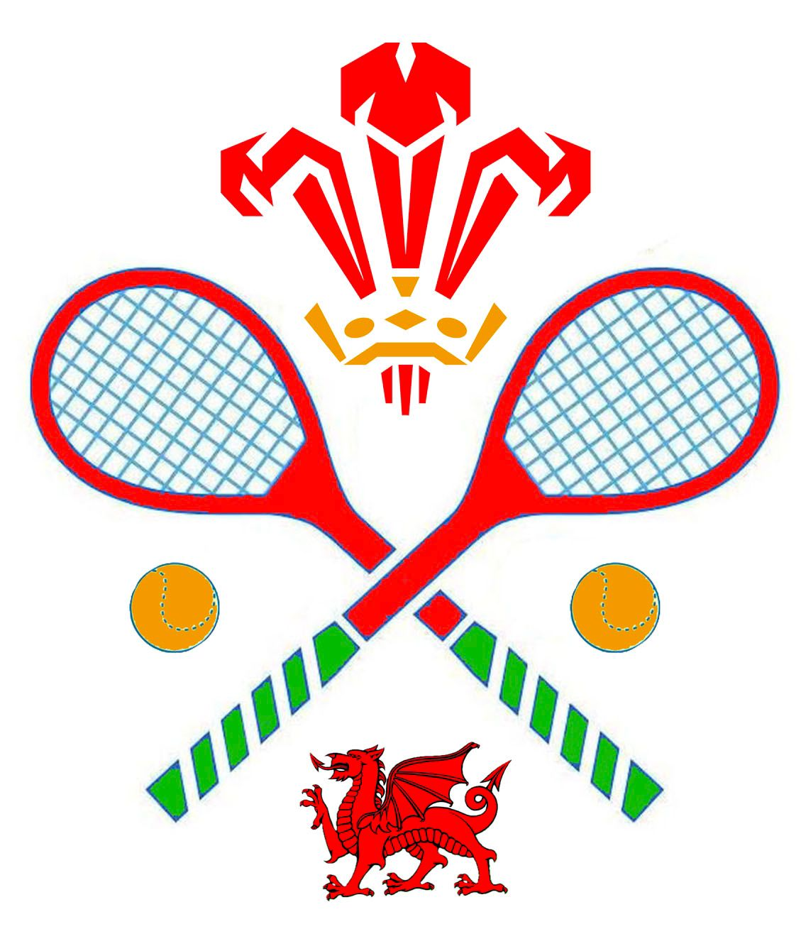

WRTA match report – National Interclub Championship 25th / 26th October 2025

Singles

On the Saturday, Jon Speirs playing with his usual power forced numerous dedans on his way past three other clubs in the box singles.
On Sunday, in the quarterfinals, the defending singles champion, Pike (Prested Hall), could not repeat the feat this year, falling to some hard hitting from Jon. However, in the semi-finals, James Holden (Leamington) provided dogged resistance to Jon’s power in a close match, Wales losing 6-5. James went on to win the singles competition.

Doubles

The debutant pairing of Michael Llewelyn-Jones and Tim Harper never quite got going despite a strong start against Ireland (the eventual winners) and a combination of owing points in each match led to a disappointing 3-nil defeat including to the 2 MMTCC pairs. As MLJ ended the day in A&E, he attributed his poor play to his increasing illness!

Everything was well organised by Tony Branfield and the teams at LTCC and MMTCC to whom go our thanks.

MLJ 28.10.25

Overall Result: Team Wales joint 4th with Manchester. Twelve teams participated.

Photo: Tim Harper (left); Michael Llewelyn-Jones (centre); Jon Speirs (right)
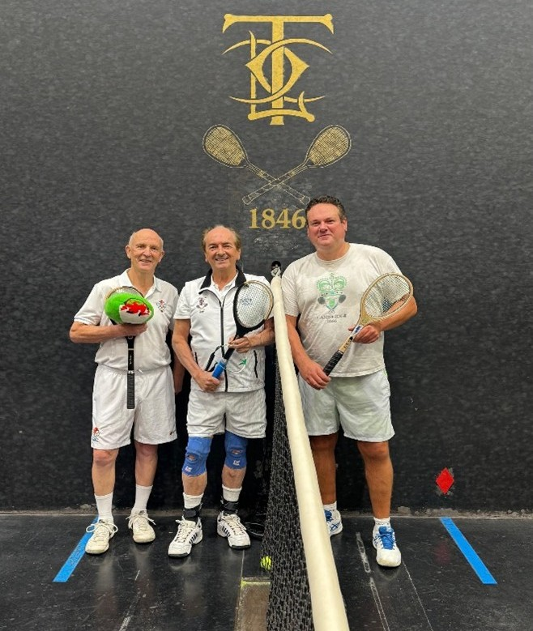

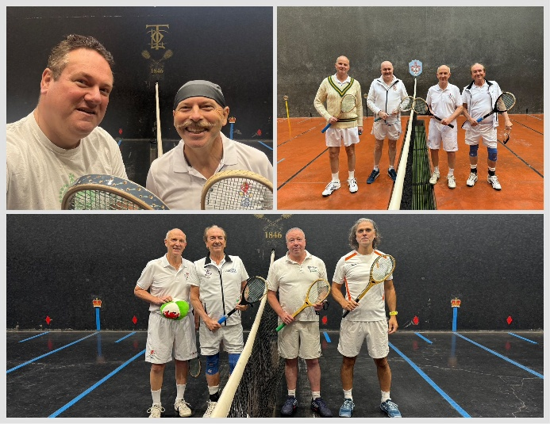

National Interclub Championship at MMTCC October 25th & 26th 2025
summary by Tony Branfield (event organiser).
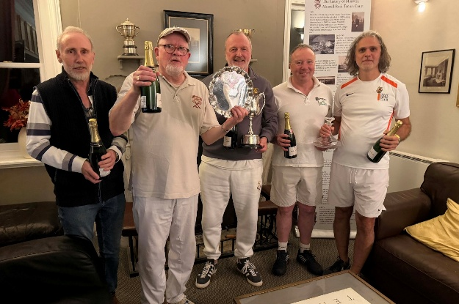

Leamington won the Team Champions Trophy with 18 points, ahead of Ireland and Prested Hall, both with 11 points.
James Holden (Leamington) won the Singles Title
Richard Ramjane and Roy Rogers (Ireland) won the Doubles Title.
In the Doubles Final, Prested Hall (Hawkey/Moreton) lost to Ireland (Ramjane/Rogers) 5/6 in a tightly contested match.
In the Singles Final, Manchester (Smith) lost to Leamington (Holden) 5/6 in a close and emotional match.
Leamington remained unbeaten heading into the semi-finals.)
Notable semi-final results:
Doubles: Prested Hall (Hawkey/Moreton) beat MMTCC (Cherry/Tippetts) 6/5.
Singles: Manchester (Smith) beat LRTA (Evers) 6/4; Leamington (Holden) beat Wales (Spiers) 6/5.
Ireland (Ramjane/Rogers) beat Leamington (Devis/Compton) in Doubles 6/3.
Several quarter-final matches were decided by close scores and comebacks, with notable wins for Manchester, Prested Hall, Leamington, Ireland, and Wales in both singles and doubles.

In the group stages:
Leamington led the team competition.
USA struggled in singles but won a doubles match against Manchester.
Prested Hall dominated doubles in Group C; LRTA’s Kate Evers topped singles.
Wales swept singles in Group B; Ireland dominated doubles.
Some “lucky loser” spots were decided by coin tosses or close game records.
The event featured competitive matches, spirited comebacks, and strong performances from multiple clubs.
The Doubles Final was a tight affair, with Ireland’s Ramjane and Rogers winning their final visit to the hazard to take the crown 6/5.
The Singles Final was closely matched, with Holden (Leamington) overcoming Smith (Manchester) 6/5 after a dramatic deciding game.

