# Wales v Scotland (AKA Celtic Challenge II)

# Saturday 13th May 2023 at Radley College.

In February 2023 at Moreton Morrell, Lloyd Pettiford orchestrated the showdown between the Principalities of Wales and Sealand with Wales prevailing 3:2. Afterwards the gauntlet was thrown down by Wales to Scotland. This was taken up by the Scottish captain Maggie Henderson-Tew who exclaimed the match as “the Celtic Challenge II”, the Scots having played Ireland for the past 5 years in the “Celtic challenge I”. Owing to the success of these events a similar format of points awarded for games won as well as the number of dedans, grille, and winning galleries hit were agreed upon. This scoring system may more accurately reflect a team's effort. See details below.

After the call to arms 19 men and women from Wales put themselves forward for the Welsh squad. The captain David Phillips being spoilt for choice selected the 9 best handicap pairings to encourage a level playing field, the unfortunate few failing to make the cut being promised further opportunities in the future.

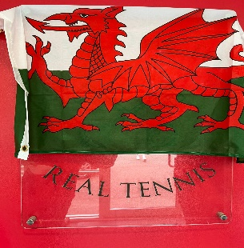The day started well despite some testing roadworks on the A34. The majority of the Welsh team were present at the off, their early arrival rewarded by some rather moreish Almond Croissants. Welsh flags flew amidst the Scottish Saltire. The going got tough from the onset. Despite a great deal of commitment and passion by the Welsh team the first 3 rubbers went to Scotland. Michael Llewlyn-Jones could not gain traction against the aggressive hitting Dan Worboys. Geraint Thomas was put under much pressure by the agile James Eadie who made some excellent retrievals. Two rubbers to nil. Michael L-J and David Phillips took to the court and looked to have parity at 3 all but then Maggie Henderson Tew found another gear and along with Dan Worboys got over the finishing line, making it 3 rubbers to nil. Danny Dawson took on Ronald Paterson with Danny retrieving well, the encounter was poised only to be disrupted by an unfortunate hamstring injury to Danny causing him to retire. Our reserve Nick Jamieson, a healthy 28hc, stepped into the breech. Despite the change in opponent, Ronald, much to his credit, adapted his game plan to take on Nick and eventually prevailed giving Scotland a 4-rubber lead.

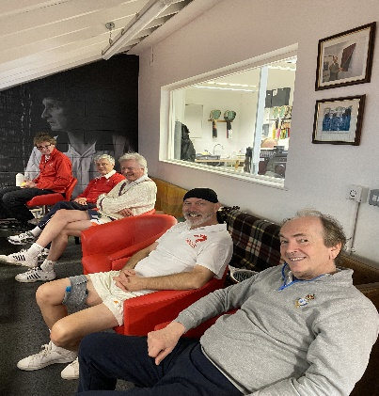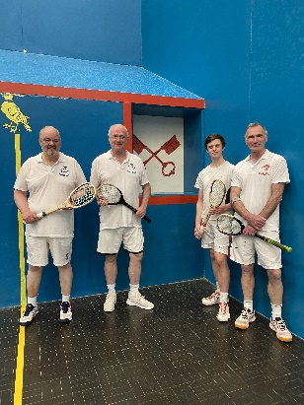Geraint Thomas and Nick Jamieson now having both played their singles matches joined as a double pairing against James Eadie and Ronald Paterson. Both instinctively played well together with much smiling and laughter. At the serving end Geraint frequently came well forward to protect the galleries and played some super shots. Nick too was enjoying himself and when at the receiving end there was one moment when his opponents thought his shot would go left, where they drifted, only for Nick to hit the ball between his legs into the Dedans much to the pleasure of his team mates. At last Wales’ first win.

The Welsh Captain buoyed up by the side’s first victory sadly could not clinch his match and was frequently on the backfoot against the agile Alison Kirkwood. Jeremy Irwin- Singer also found himself under pressure against Calum Maclean who managed to control the match from the serving end. Chris Lewis relatively new to the game took on the wily campaigner Bob Compton. There were moments when Chris put Bob under pressure, but Bob found eventually dominated hitting the 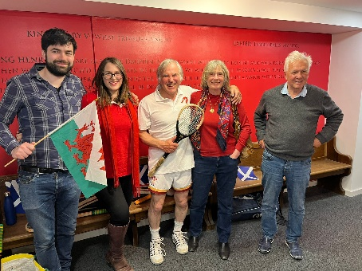Dedans on 4 occasions and grille on two.

A pause from the tennis when both sides came on court to face each other at the hazard end to sing their National Anthems (official and non official), Wales “Mae Hen Wlad Fy Nhadau” and Scotland the “Flower of Scotland”. By now Guy Fielding’s family had arrived en-mass some wearing patriotic red shirts.

Despite Scotland’s small but perfectly formed team the Welsh outnumbered them with their voices filling all reaches of the court.

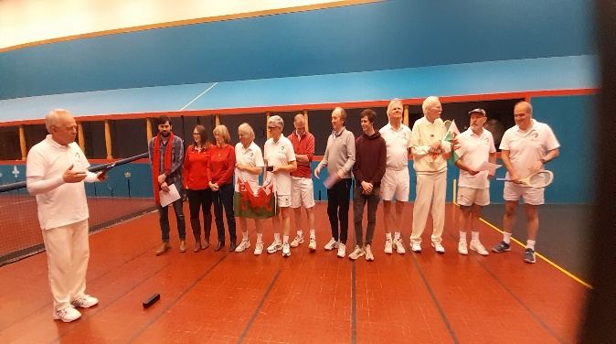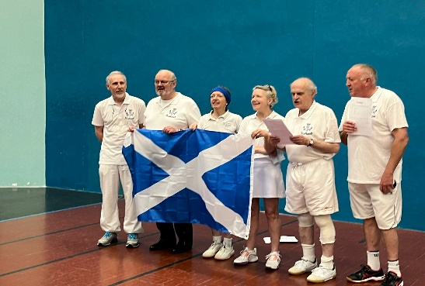

Chris Ronaldson saying afterwards there was little doubt who had won that show down. Wales were awarded 100 points for their vocal dominance.

Back to combat. Owen Darbishire had arrived for the National Anthems after fulfilling his academic work and took on Maggie H-T who played inspiringly, hitting a good length. She also retrieved a memorable return left-handed from under the Grille, eventually prevailing over Owen.

Jeff Avery and Guy Fielding came on to play Miles Buckingham and Jeremy Garson. The Fielding brigade were fully behind their man who scurried around. Both men gave their all but the steady Miles Buckingham with good drag serves and Jeremy Garson had the greater firepower. Guy Fielding stayed on court to be joined by Chris Lewis. Chris’ nemesis Bob Compton joined Miles. The Scottish pair having played a lot of tennis together foiled Guy and Chris’s heroic efforts. Jeremey Irwin-Singer and Owen Darbishire were next on wincing from their singles defeats. They were not going to be unsettled by the graceful Alison Kirkwood and enthusiastic Calum Maclean. Owen led the charge hitting the only winning gallery of the day by either team. Jeremy found his natural rhythm and the two complemented each other's style bringing at last, our second Welsh victory 6:4. Jeff Avery also aggrieved from previous defeat came on court with a steely gaze to salvage some Welsh pride. This he did by cunningly hitting the ball late when his opponent Jeremy Garson had committed to a certain path. He called on all his experience and managed his battle well winning the final rubber 6:3

Score line Scotland 10 rubbers to Wales 3.

Under the novel scoring system Scotland 591 points Wales 581. The generous gift of 100 points to Wales for their singing nearly backfired on the Scots!

The day was rounded off by the Welsh captain thanking in Welsh and English the Scots, Radley Club and the professionals for a memorable day of competition also congratulating Scotland on their victory. The Scottish captain, Maggie Tew Henderson -Tew spoke responded and fizz was distributed for the toasts.

The Welsh player of the day as determined by the points scored was Owen Darbishire (71) and the Scots equivalent was Bob Compton (98). Both received a bottle of wine.

The Welsh most valuable player of the day was awarded to Geraint Thomas for his determined defence of the galleries with some super reflex shots and the Scottish award went to their captain Maggie Tew-Henderson for a stunning shot from under the grille. The Tunnock’s trophy was presented to Scotland.

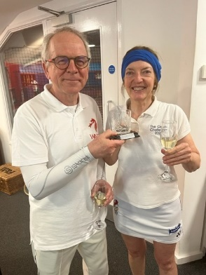 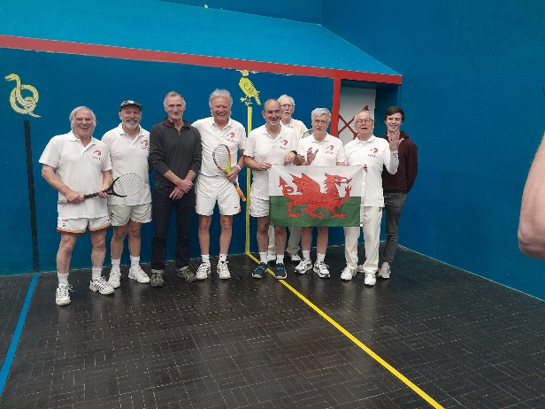 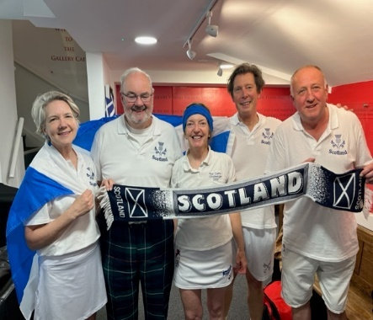

There was no arguing with the score line in that Scotland deserved to take the day. Wales have learnt from this bruising defeat. The battle was lost but the “war of sporting contest” will continue! A good day was had by all.

David Phillips

Welsh Captain.

Attached the detailed score sheets.

Each rubber was a single set with the victor first to 6 games

10.00 Michael Llewelyn-Jones v Dan Worboys 1:6 Scotland

10.35 Geraint Thomas v James Eadie 3:6 Scotland

11.10 Michael Llewelyn-Jones & David Phillips v

Dan Worboys & Maggie Henderson-Tew 3:6 Scotland

11.45 Danny Dawson (Nick Jameison substitute) v Ronald Paterson 3:6 Scotland

12.20 Geraint Thomas & Danny Dawson (Nick Jameison substitute) v James Eadie & Ronald Paterson 6:3 Wales

12.55 David Phillips v Alison Kirkwood 4:6 Scotland

1.30 Jeremy Irwin-Singer v Calum Maclean 2:6 Scotland

2.05 Chris Lewis v Bob Compton 3:6 Scotland

**2.35 All players on court for anthems**

2.40 Owen Darbishire v Maggie Henderson Tew 2:6 Scotland

3.15 Jeff Avery & Guy Fielding v Jeremy Garson & Miles Buckinghamshire 3:6 Scotland

3.50 Chris Lewis & Guy Fielding v Bob Compton & Miles Buckinghamshire 3:6 Scotland

4.25 Jeremy Irwin-Singer & Owen Darbishire v Alison Kirkwood & Calum Maclean 6:4 Wales

5.00 Jeff Avery v Jeremy Garson 6:3 Wales

