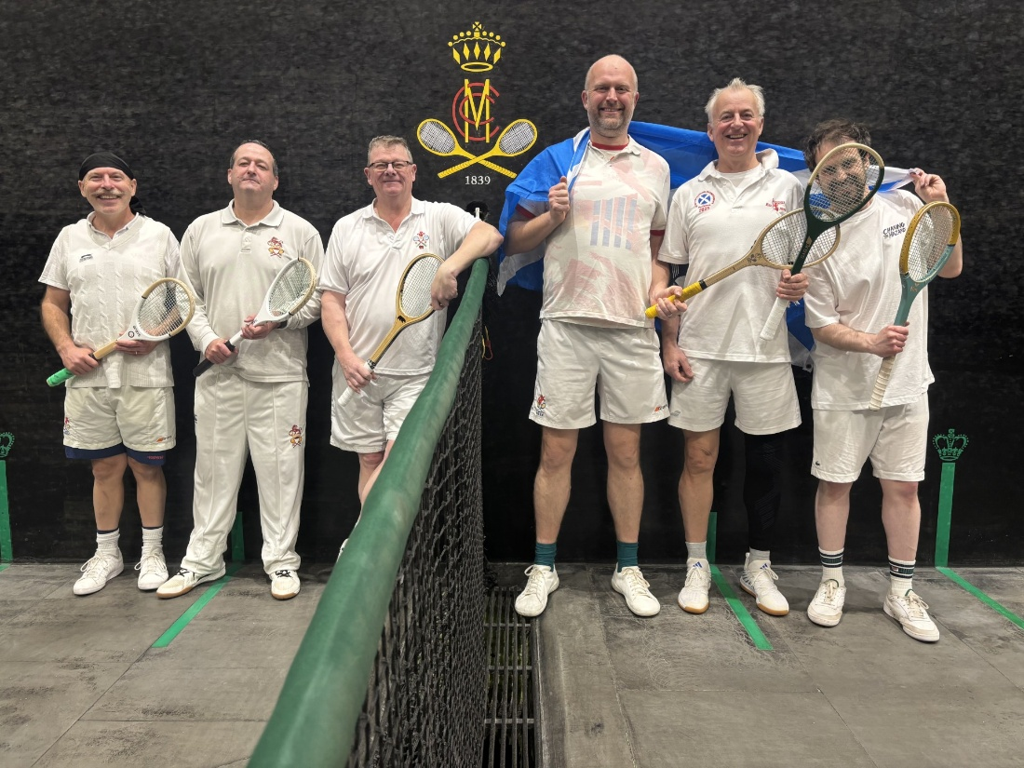

Wales ( L/R : Danny Dawson, Peter Lewis & Derek Williams)
Scotland (L/R : Ewan Smith, Ian Falconer & Dan Worboys)

MCC was to be the host venue for this very enjoyable, competitive fixture on the eve of the corresponding Rugby International.
Scotland's Dan Worboys proved too consistent and adapted better to the peccadillos of the court winning the first singles rubber convincingly against Danny Dawson.
The Welsh pairing of Peter Lewis & Dawson however fought back strongly to overcome Worboys & Ian Falconer 6-4 in the first doubles making the match score 1-1.
Lewis against Falconer was the next singles rubber. Home court knowledge and some lovely shots belying his handicap gave the Scot the honours.
Again, the match was to draw level at 2-2 owing to Dawson & Derek Williams beating Worboys & Ewan Smith in the next confrontation. The contest was a bit of a 'rollercoaster' with the Welsh pair taken a back how they gained the 6-4 win!
The final singles between Scotland's Smith and Williams of Wales carried the most significant handicap difference and this ultimately told. Ewan stormed into a 4-0 lead and although Derek fought back bravely to 4-3 and had points to draw level, the Scot was eventually victorious 6-3.
The match score was now 3-2 and Wales needed to win the remaining rubber to secure an honourable 3-3 draw. So far there had been a notable pattern: Scotland winning the singles and Wales the doubles. Unfortunately, the hope that this was to continue was dashed with Falconer & Smith beating Lewis & Williams in the last rubber. A deserved, hard fought 4-2 victory for the Scots was the final match result.

A fantastic evening was had by All and a big thank you to Ian Falconer and Dan Worboys for organising.

Report by our Team Captain - Danny Dawson

