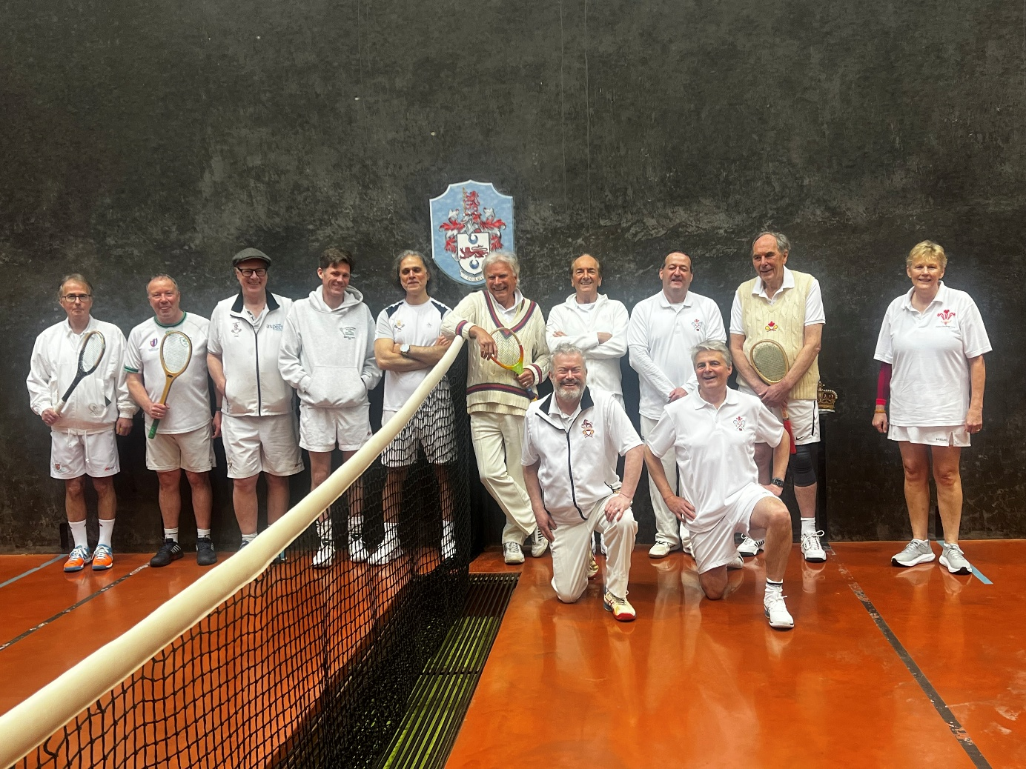

Wales - Lloyd Pettifer, Peter Lewis, Vaughan Williams, Michael Llewelyn-Jones, Jeremy Irwin-Singer, Edward Nottingham and Jenny Jones

Ireland - Roland Budd, Mark Heffernan, Richard Ramjane, Paul Brennan and Roy Rogers

Wales had a larger squad, but Ireland had better players and had warmed up the evening before at Leamington (a lesson for Wales for the future?)

In a close encounter and one of few level games, Wales opened well with Edward Nottingham pulling back from 3-4 to win 6-4 in the first tie against Roy Rogers.
Jenny Jones followed with astute use of handicap advantage against Roy Rogers to win 6-1 and record a second win for Wales. A good Welsh start.
In the first doubles Lloyd Pettifer and Vaughan Williams opened well but then slid from 1-0 to 1-7 before rallying a little against Roland Budd and Richard Ramjane but still lost 3-8.
Then Richard Ramjane remained on court and despite giving 30 owe 15 in handicap he raced to 4-0 only for Michael Llewelyn-Jones to charge back to 4-4. Michael could not maintain his charge and lost 4-6. The match now Wales 2 Ireland 2.
Peter Lewis recovering from injury could not find his length and was overtaken just before lunch 6-0 by Paul Brennan, striking the first winning gallery en route.

Ireland went into lunch 3-2 ahead. However, they were impressed by the Welsh anthem sung tunefully unaccompanied.

Edward Nottingham and Jenny Jones held on in a tense and crucial first tie after lunch against Richard Ramjane and Roy Rogers. They clawed back to 4-4 and then reached 6-4.Not over, it's doubles and had to continue but reached 8-4, phew! Wales 3 Ireland 3.
Well, done Jenny and Edward in each winning both their ties.
So now at 3 all for either team to win they have to win 3 of the last 4 ties.
Then a really close tie with neither Vaughan Williams nor Mark Heffernan ever being more than a game ahead. They reached 5-5 , 40 all but the final point had an Irish swerve.
Another very close tie followed and saw Jeremy Irwin -Singer creep back to 4-4 and then 5-4 against Paul Brennan. But it then went to 5-6 and the captain's loss meant Wales could only now draw the match. However, when he learnt his opponent was 7 yrs younger with a 15 lower handicap, Jeremy didn't feel too bad.
The penultimate tie was more doubles. Peter Lewis and Michael Llewelyn-Jones against Roland Budd and Mark Heffernan. The haute couture of Michael's green white and gold goggles much admired by the Irish and despite some great volleying from Peter to reach 7-7, Wales again lost by the odd game 8-7 and with it the match. Perhaps it was confirmation that despite handicap disadvantages superior players will generally win.

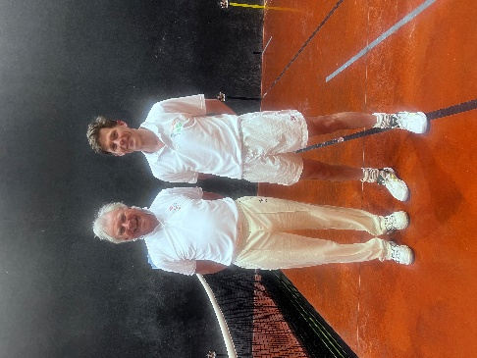
So, to the final tie between the captains. A coaching lesson for Jeremy Irwin-Singer against the elegant Roland Budd ? Poor Roland with 30 owe 30, one serve and no tambour could afford no mistakes. But he struck the tambour once to lose a game and only made 2 mistakes and managed to lose most unfairly 6-3.

So, the result in a most enjoyable and congenial day and actually a surprisingly close set of games.

Wales 4 Ireland 6

Thanks very much to Lloyd Pettifer for his organising and fine marking.

Wales Captain and report by Jeremy Irwin Singer

